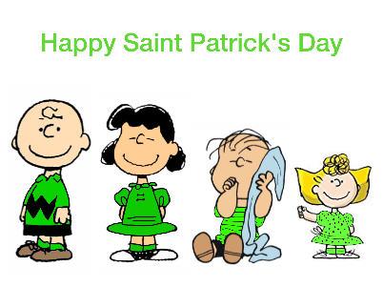
2024
Monday | Tuesday | Wednesday | Thursday | Friday
 |  |  |  | 1
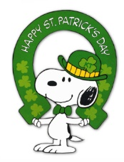 |  |  |  | BREAKFAST  BREAKFAST SANDWICH  LUNCH  SAUSAGE PIZZA or YOGURT W/ GRANOLA
4 | 5 | 6 | 7 | 8
BREAKFAST  BAGEL  LUNCH  GRILLED CHICKEN SANDWICH or  YOGURT W/ GRANOLA | BREAKFAST  PANCAKES & BACON  LUNCH  WALKING TACO or YOGURT W/ GRANOLA | BREAKFAST  OATMEAL  LUNCH  SHEPHERD’S PIE or YOGURT W/ GRANOLA | BREAKFAST  BREAKFAST SCRAMBLED  LUNCH  BBQ PORK SANDWICH or YOGURT W/ GRANOLA | BREAKFAST  BREAKFAST PIZZA  LUNCH  PEPPERONI PIZZA or YOGURT W/ GRANOLA
11 | 12 | 13 | 14 | 15
BREAKFAST  MUFFIN  LUNCH  CORN DOG or  YOGURT W/ GRANOLA | BREAKFAST  FRENCH TOAST  LUNCH  QUESADILLA or YOGURT W/ GRANOLA | BREAKFAST  TORNADOS  LUNCH  CHICKEN ALFREDO or YOGURT W/ GRANOLA | BREAKFAST  CHURRO  LUNCH  HAMBURGER or CHEESEBURGER or YOGURT W/ GRANOLA | BREAKFAST  BISCUITS & GRAVY  LUNCH  CHEESE PIZZA or YOGURT W/ GRANOLA
18 | 19 | 20 | 21 | 22
BREAKFAST  DONUT  LUNCH  SLOPPY JOE or YOGURT W/ GRANOLA | BREAKFAST  PANCAKE ON A STICK  LUNCH  NACHOS or  YOGURT W/ GRANOLA | BREAKFAST  BREAKFAST BURRITO  LUNCH  CHICKEN POT PIE or YOGURT W/ GRANOLA | BREAKFAST  BREAKFAST SCRAMBLE  LUNCH  CHICKEN SANDWICH or YOGURT W/ GRANOLA | BREAKFAST  CINNAMON ROLL  LUNCH  SAUSAGE PIZZA or YOGURT W/ GRANOLA
25 | 26 | 27 | 28 | 29
BREAKFAST  BAGEL  LUNCH  CHICKEN NUGGETS or YOGURT W/ GRANOLA | BREAKFAST  WAFFLES  LUNCH  BURRITO or  YOGURT W/ GRANOLA | BREAKFAST  OATMEAL  LUNCH  BAKED CHICKEN or YOGURT W/ GRANOLA | BREAKFAST  BREAKFAST BURRITO  LUNCH  HOT DOG or  YOGURT W/ GRANOLA | BREAKFAST  BREAKFAST SANDWICH  LUNCH  PEPPERONI PIZZA or YOGURT W/ GRANOLA
**MENU SUBJECT TO CHANGE WITHOUT NOTICE**
This institution is an equal opportunity provider and employer.
Students that bring cold lunch should bring their own silverware (NO knives, please).
Please DO NOT send packages that your child cannot open.
**BREAKFAST INCLUDES**
A main dish or cold cereal, a fruit and a milk
**LUNCHES INCLUDE**
A main dish or yogurt w/granola, a fruit, hot vegetable, salad bar, and a milk

